**Daily Scrum or Standup Meeting**

Team name: Group 8_________________________

Scrum Master: Cole_______________________

Date: 3-1-2021_______________________________

|  |  |  |  |
| --- | --- | --- | --- |
| **Team Member** | **What did you do since the last scrum?** | **What do you plan to do before the next scrum?** | **What obstacles do you have?** |
| Cole | Recharged a little after finishing milestone 2 | Work on getting React up and going | Lack of experience with React |
| Jeremy | Caught up on homework | Get started on Django APIs | None |
| Austin | Got some sleep | Continue working on customer-facing interfaces | Time |
| Logan | Spent time with family | Start learning React | Time |
|  |  |  |  |

# Burndown

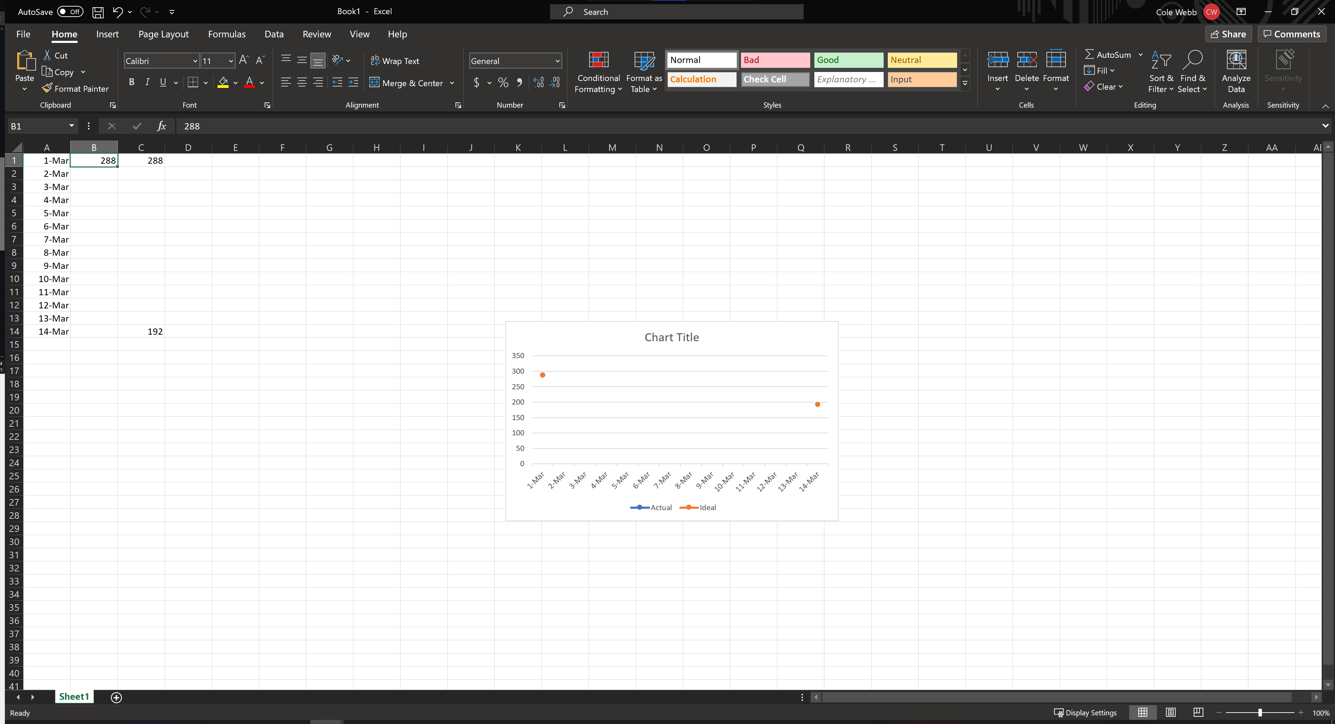

# Screenshot of you project board

